SIMATS ENGINEERING (SAVEETHA SCHOOL OF ENGINEERING)
Department of Computer Science and Engineering
CO5 ASSESSMENT TOOL 1 – Research Paper Review / Lite+rature Survey

Course Code: | CSA10 | Course Title: | Software Engineering
CO Assessed: | CO5 | Assessment: | Assessment Tool 1 – Research Paper Review / Literature Survey
Weightage: | 20% | Total Marks: | 25
CO5 Statement: | Evaluate emerging technologies and societal impacts, maintaining and evolving software systems responsibly
Student Name: | Surya Krishna Teja Yandra | Reg. No.: | 192425065
Date: | 27-08-2026 | Duration: | 60 minutes

Code of Conduct
I Surya Krishna Teja Yandra/192425065 (Name / Reg No) certify that this submission is my original work and that I have adhered to the guidelines specified for this assessment. I understand that any violation of academic integrity rules will result in disciplinary action.
Signature of the Student: _________________________
Annexure A – Research Paper Review / Literature Survey
Instructions to Students:
Each student is assigned an individual problem statement. Based on the assigned problem statement, conduct a literature survey and review relevant research papers to understand the existing approaches, techniques, technologies, limitations, and research gaps related to the problem.
The literature survey should include:
- Identify and select relevant research papers related to the assigned problem statement from reputed journals, conferences, or scholarly databases.
- Summarize the objectives, methodologies, technologies, datasets, and major findings of the selected research papers.
- Compare the existing approaches based on suitable parameters such as accuracy, performance, scalability, efficiency, methodology, or other problem-specific metrics.
- Identify the limitations and challenges of the existing research approaches.
- Analyze the literature to identify the research gap or unresolved issues related to the assigned problem.
- Discuss the possible improvements or future research directions based on the identified research gap.
- Prepare a comparative literature survey table containing details such as author/year, research problem, methodology, dataset/tools, key findings, limitations, and research gap.
- Provide proper citations and references using a consistent referencing style.
Deliverable: Submit a Research Paper Review / Literature Survey Report containing the selected research papers, individual paper reviews, comparative analysis, identified research gaps, future directions, and properly formatted references.

Rubrics for Calculation
Evaluation Criteria | Excellent (4 Marks) | Good (3 Marks) | Satisfactory (2 Marks) | Needs Improvement (1 Mark)
Selection & Review of Research Papers(25%) | Selects highly relevant, recent, credible papers and provides comprehensive reviews of objectives, methodology, tools, datasets, and findings | Selects relevant papers and provides good reviews with minor gaps | Selects moderately relevant papers with basic reviews | Papers are irrelevant or reviews are incomplete
Comparative Analysis(20%) | Provides a detailed comparison of methodologies, tools, datasets, results, and performance using a clear comparison table | Provides a good comparison with relevant parameters | Provides limited comparison with few parameters | Little or no meaningful comparison
Critical Analysis & Research Gap(25%) | Clearly analyzes limitations and identifies significant, well-supported research gaps | Identifies relevant limitations and research gaps | Identifies basic gaps with limited analysis | Research gaps are unclear or missing
Future Directions & Relevance(15%) | Proposes practical and innovative future directions directly relevant to the assigned problem statement | Proposes relevant future directions | Provides general future suggestions | Future directions are missing or unrelated
Documentation, Citations & References(15%) | Excellent academic structure, clear presentation, accurate citations, and consistent referencing | Well-organized with minor formatting/citation issues | Adequately documented with some errors | Poorly organized with inadequate or incorrect references

Criteria | Mark
Selection & Review of Research Papers(25%) | /5
Comparative Analysis(20%) | /5
Critical Analysis & Research Gap(25%) | /5
Future Directions & Relevance(15%) | /5
Documentation, Citations & References(15%) | /5
TOTAL | /25

AI-Driven Smart Disaster Relief Resource Allocation and Volunteer Coordination Platform

1. Research Problem
- Disaster response involves large numbers of:
  - Relief materials
  - Volunteers
  - Rescue teams
  - Vehicles
  - Shelters
  - Medical supplies
- Manual coordination can cause:
  - Delayed assistance
  - Unequal resource distribution
  - Volunteer-resource mismatch
  - Transportation problems
  - Shortages and duplication
- AI can analyze disaster severity, population, resource availability, volunteer skills, and location to recommend better allocation decisions.
- GIS can provide spatial information for affected areas and transportation routes.
- Real-time dashboards can help government agencies, NGOs, and emergency teams make faster decisions.

2. Selection & Review of Research Papers

Paper 1: Joint Scheduling Policy for Volunteers and Materials in Multi-Organizational Disaster Response — 2026
- Authors: Bo Feng, Qingchun Meng, Guodong Yu
- Methodology: Markov Decision Process + Hierarchical Deep Reinforcement Learning (HDRL)
- Focus: Joint allocation of volunteers and relief materials.
- Important factors: Volunteer skills, task priorities, material availability and organizational constraints.
- Finding: The proposed controller reduced task backlogs by approximately 30–85% and personnel costs by 16–42% compared with common heuristics.
- Limitation: Large-scale environments can increase the state and action spaces, creating scalability challenges.
- Relevance: Highly relevant because the proposed platform also combines volunteer coordination and resource allocation.
Paper 2: Spontaneous Volunteer Task Assignment in the Acute Phase of Disaster Response — 2026

- Methodology: Dynamic multi-period Mixed Integer Programming (MIP).
- Focus: Assignment of spontaneous volunteers to disaster-response tasks.
- Important factors: Task arrivals, volunteer availability, task completion and reassignment.
- Objective: Minimize the total time required to resolve disaster-response tasks.
- Contribution: Models realistic situations where disaster tasks can exceed the available volunteer workforce.
- Relevance: Useful for developing the platform's automatic volunteer assignment module.
Paper 3: Prioritisation Recommendation Mapping (PrioReMap) — 2026

- Methodology: GIS + Bayesian Network + Expected Loss framework.
- Focus: Prioritizing areas requiring urgent relief.
- Application: Flood disaster response.
- Advantage: Helps decision-makers prioritize locations despite incomplete information and time pressure.
- Case study: Extreme flood scenario in Cologne, Germany.
- Relevance: Directly supports the proposed AI-based disaster severity and priority prediction module.
Paper 4: AI-Based Framework for Earthquake Relief Demand Forecasting

- Methodology: AI-based demand forecasting.
- Data: Latitude, longitude, population, demand, supply, cost, deaths, injuries, infrastructure damage and cascading disasters.
- Purpose: Predict relief requirements in affected areas.
- Contribution: Supports better forecasting of emergency resource requirements.
- Relevance: Useful for predicting food, medicine, shelter and other relief requirements.
Paper 5: Multi-Objective Dynamic Resource Allocation for Search and Rescue

- Methodology: Two-stage stochastic programming + multi-objective optimization.
- Resources: Volunteers, rescue personnel and material resources.
- Objective: Minimize unmet human and material demand and unnecessary resource transfers.
- Case study: Earthquake scenario in Istanbul's Kartal district.
- Contribution: Integrates volunteers with official rescue personnel and material resources.
- Relevance: Provides a strong foundation for the proposed multi-resource allocation engine.

3. Comparative Analysis

Research Paper | Methodology | Main Focus | Strength | Limitation
Feng et al. 2026 | HDRL + MDP | Volunteers + materials | Dynamic real-time allocation | Scalability
Volunteer Task Assignment 2026 | MIP | Volunteer assignment | Realistic dynamic tasks | Computational complexity
PrioReMap 2026 | GIS + Bayesian Network | Area prioritization | Handles incomplete information | Focused mainly on flood scenario
Earthquake Demand Forecasting | AI forecasting | Relief demand | Predicts resource requirements | Earthquake-focused
Dynamic Resource Allocation | Stochastic programming | Human + material resources | Multi-objective allocation | Requires optimization models and data

Overall comparison
- AI/ML: Best for prediction and adaptive decision-making.
- Deep Reinforcement Learning: Best for dynamic allocation.
- MIP: Suitable for structured volunteer assignment.
- GIS: Best for location-based prioritization and visualization.
- Stochastic optimization: Useful when disaster conditions are uncertain.
- Proposed system: Combines these technologies into one integrated platform.

4. Critical Analysis & Research Gap

Existing limitations
- Many studies focus on one resource type, such as volunteers or relief materials.
- Volunteer allocation and material distribution are often treated as separate problems.
- Some models focus on a specific disaster, such as earthquakes or floods.
- Real-time data integration is limited.
- Transportation route optimization is not always integrated with resource allocation.
- Cross-agency coordination remains difficult.
- AI models may require large and high-quality datasets.
- Complex reinforcement-learning models may face scalability problems.
- Human decision-makers still need to validate AI recommendations.
- Privacy and security of volunteer and disaster-location data need consideration.

Major Research Gap
There is a need for an integrated AI-driven platform that simultaneously handles disaster prioritization, relief-resource allocation, volunteer assignment, real-time inventory monitoring, GIS-based route optimization and multi-agency coordination.
The research literature already demonstrates strong individual approaches for volunteer scheduling, GIS prioritization, demand forecasting and resource optimization, but these capabilities are generally distributed across separate models.

5. Proposed System
Main Modules

1. Disaster Data Collection
- Disaster type
- Severity
- Affected population
- Location
- Infrastructure damage
- Emergency requests

2. AI Priority Prediction
- Predicts urgency of each affected location.
- Assigns priority scores.
- Identifies critical areas.

3. Resource Management
- Food
- Water
- Medicine
- Clothing
- Shelter materials
- Rescue equipment

4. Volunteer Management
- Volunteer location
- Skills
- Availability
- Experience
- Task assignment

5. AI Resource Allocation
- Matches resources with demand.
- Prioritizes critical areas.
- Minimizes resource shortages.

6. Route Optimization
- Uses GIS and road-network information.
- Finds efficient delivery routes.
- Considers blocked or damaged roads.

7. Real-Time Dashboard
- Resource inventory
- Volunteer status
- Disaster severity
- Pending requests
- Delivery status
- Emergency alerts

8. Multi-Agency Coordination
- Government departments
- NGOs
- Hospitals
- Rescue teams
- Community volunteers

6. Proposed Architecture

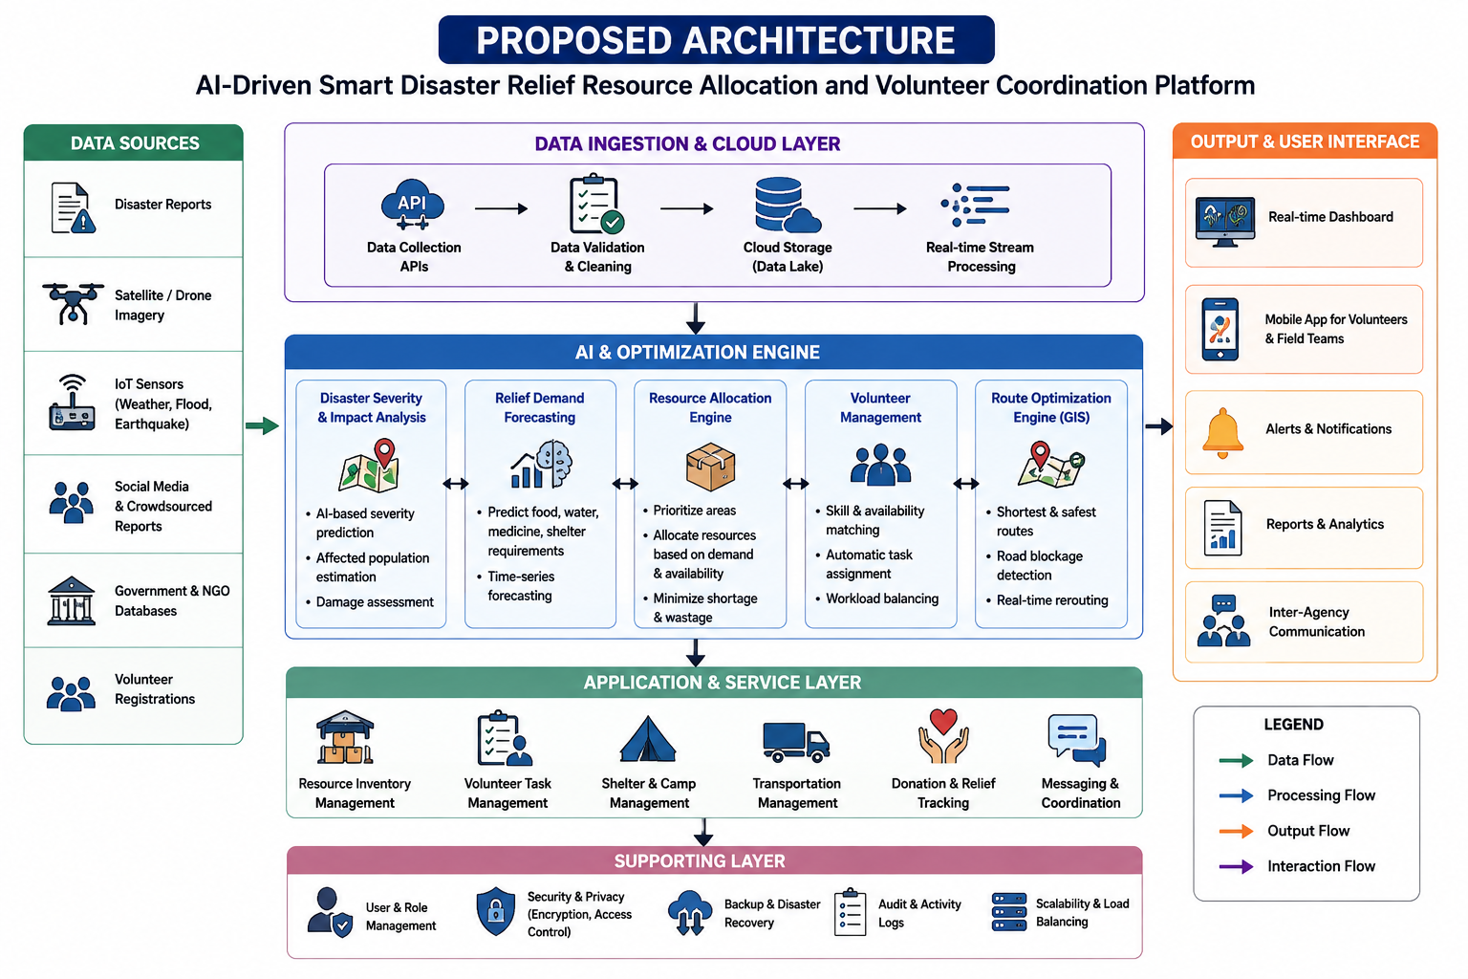
7. Future Directions & Relevance

Future Improvements
- Use Deep Reinforcement Learning for continuously changing disaster conditions.
- Integrate satellite and drone imagery for damage detection.
- Use IoT sensors for real-time disaster information.
- Add predictive models for future resource demand.
- Integrate weather and traffic information.
- Develop multilingual emergency communication.
- Add blockchain-based relief transaction tracking.
- Improve AI explainability so authorities understand recommendations.
- Develop offline functionality for areas with poor connectivity.
- Add fairness constraints to ensure vulnerable communities receive appropriate assistance.
Recent research is already moving toward reinforcement-learning-based dynamic allocation, AI-based demand prediction, GIS-supported prioritization and intelligent humanitarian logistics, making these directions directly relevant to the proposed platform.

8. Expected Outcomes
- Faster relief distribution
- Reduced resource wastage
- Better volunteer utilization
- Reduced response time
- Improved transportation efficiency
- Accurate disaster-area prioritization
- Real-time resource visibility
- Better coordination between agencies
- Improved emergency decision-making
- Increased transparency
- Improved community resilience

9. Documentation, Citations & References

Key References
- Feng, B., Meng, Q., & Yu, G. (2026). Joint scheduling policy for volunteers and materials in multi-organizational disaster response. Omega, 141, 103505.
- Spontaneous Volunteer Task Assignment in the Acute Phase of Disaster Response: A Rolling-Horizon MIP Approach. Sustainability, 18(10), 4915, 2026.
- Prioritisation Recommendation Mapping (PrioReMap): A method for supporting relief coordination in flood disaster response. International Journal of Disaster Risk Reduction, 132, 105949, 2026.
- An AI-based framework for earthquake relief demand forecasting: A case study in Türkiye. International Journal of Disaster Risk Reduction, 2024.
- A Multi-Objective Dynamic Resource Allocation Model for Search and Rescue and First Aid Tasks in Disaster Response by Employing Volunteers. Journal of Disaster Risk Reduction / MDPI, 2025.
- Vahdani, B. (2023). A flexible framework to coordinate debris clearance and relief distribution operations: A robust machine learning approach. Expert Systems with Applications, 229, 120512.

